DSDP Maths for Data Science

Exercise Guide

**Contents**

Module objectives 3

01 Matrices with NumPy 4

02 Matrix Arithmetic 5

Inverses and Solving Simultaneous Equations 9

04 Matrix Transformations 13

Exercise 1 13

Exercise 2 15

05 Vectors and Dot Product 18

Exercise 1 18

Exercise 2 19

06 Vector Spaces 25

07 Differentiation and Gradients 25

Discussion and exercise 25

Discussion 28

Paired Exercise 29

08 Introduction to Gradient Descent 30

Discussion 30

Exercise 31

09 Linear Regression with Gradient Descent 32

Exercise 32

10 Set Building and Mathematical Notation 33

Group Activity 33

Activity 35

Group Challenge 35

Activity 35

Activity and Discussion 36

# Module objectives

* Use Python with NumPy to build mathematical structures including vectors and matrices.
* Interpret the results from operations and processes involving vectors and matrices and identify example use cases.
* Describe the solution to a linear problem using a matrix-vector product and explore the effect of matrix transformations.
* Estimate and calculate gradients using numerical methods and standard calculus results.
* Identify when the differentiation techniques chain rule, product rule, and partial differentiation are needed.
* Apply a gradient descent algorithm step by step on a simple polynomial function to verify the analytic solution and identify how the algorithm can be modified by choosing an alternative loss function.
* Perform gradient descent step by step to calculate a regression line using chain rule and partial differentiation.
* Use QA’s notation reference guides to build mathematical sets and practise interpreting the mathematics communicated in published journal articles or books.

## 

# DSDP Mathematics

# 01 Matrices with NumPy

Use the following NumPy methods to create NumPy arrays:

1. np.identity(n) or np.eye(n), where n is the dimension of a square array
2. np.array(). Create appropriate contents to produce an example of a column
3. np.ones(n, m), where the dimension of the array is n x m
4. np.empty(n, m)
5. np.arrange(start, exclusive_end, step). Use this to produce a row of values starting at 1, going up to but not including 15, in steps of 3
6. np.linspace(start, end, no_of_values). Use this to produce 5 values that start at 0 and go up to 1.
7. np.random.rand(n,m) or np.random.randn(n,m). Use these to create an n x m array filled with random numbers between 0 and 1, or from the standard normal distribution.
8. np.full((n,m), value). Creates an n x m array filled with the value of your choice.
9. np.tile(base_array, number). Save one of your previous answers and explore how this method can be used to tile repeated copies of it as a single array.

## Solutions

# 02 Matrix Arithmetic

1. Create an example that uses at least one 3x2 matrix to demonstrate matrix subtraction.



1. Re-create matrix2 from the earlier example. Calculate:
2. matrix2 multiplied by a scalar
3. matrix2 divided by a scalar
   1. What does matrix2.ravel() do?
   2. What does np.gcd.reduce(matrix2.ravel()) do?
4. Divide matrix2 by the largest whole number you can that then leaves all elements in the answer as whole numbers.
5. Attempt to do the multiplication BA so you can observe the error produced.

* 1. Re-create the example showing the multiplication AB and multiply the answer by a scalar.
  2. Calculate C = scalar*A (using the same scalar as before).
  3. Calculate CB. Does it matter if a matrix is multiplied by a scalar and secondly by a matrix vs. multiplying the matrices and secondly by the scalar?

1. Create a 3x3 matrix C and a 3x3 identity matrix I. Calculate CI and IC. What do you notice?
2. By hand: X is the 3x1 column matrix containing x,y,z. Write down the resulting matrix when the multiplication CX is carried out. Note that each element will be an algebraic expression.

## Solutions for discussion

# 03 Inverses and Solving Simultaneous Equations

* 1. Create a 2x2 matrix and name it E.
  2. Calculate the inverse.
  3. Check that multiplying your previous answers together (in each order) gives the identity matrix.

**2.** The determinant of a 2x2 matrix [[a,b],[c,d]] is defined as ad – bc

**a.** Check that np.linalg.det(E) gives the determinant correctly

**b.** The determinant is calculated as part of the process that np.linalg.inv() follows to find the inverse. Using your previous answers, can you see how the inverse can be worked out for a 2x2 matrix? (Try different values within E to explore).

**3.** Consider the 3 linear equations below that we would like to solve simultaneously. (The values of x, y, and z that make all 3 equations correct).

# 10 x + 2 y + 2 z = 20

# 41 x + 15 y + 6 z = 30

# 27 x + 83 y + 59 z = 40

**a.** **By hand:** Write the expressions from the left-hand side in a 3x1 matrix and write the values from the right-hand side in a second 3x1 matrix.

**b.** **By hand:** Write down the 3x3 matrix which would multiply [[x],[y],[z]] to give your first 3x1 matrix. Name this C.

**c.** Using python: Calculate C inverse.

**d.** Solve CX = D using python. Hint: Make X the subject.

**4.** Solve these simultaneous equations using matrices:

**a.** x + y = 1 and 2x + 3y = 7.

Check that the values of x and y found satisfy both equations.

**b.** 3x + 4y + 5z = 6 and 7x + 8y + 9z = 10 and 11x + 12y + 13z = 14

**5.** Explore what happens if both equations are multiples of each other. What is the determinant of the matrix of coefficients? e.g. x + y = 1 and 2x + 2y = 2

## Solutions for discussion

# 04 Matrix Transformations

## Exercise 1

1. Recreate the example.
2. Using matrix multiplication and each point represented by a 2x1 matrix, check that the points (0,1), (1,0), and (3,4) are transformed to (2,0), (0,2), and (6,8) by the matrix 2I.
3. Find the inverse of 2I and check that transforming (2,0), (0,2), and (6,8) returns to the original points.
4. Are there any points that would not move when they are transformed? We call these invariant points.
5. a) Try other 2x2 matrices - explore the effect on the area of the triangle and the value of the determinant.
6. b) If we say a 2x2 matrix is [[a,b],[c,d]], where will the points (1,0) and (0,1) be transformed to?

## Solutions to discuss

## Exercise 2

* 1. Where are the points (1,0) and (0,1) transformed to?
  2. Where are (0,0) and (1,1) transformed to?

2. Plot the 4 transformed points.

3. Is the shape made by the 4 new points a square still? Which directions do the points appear to have been stretched in?

4.

a. First eigenvector: Transform these points (0.89442719, 0.4472136) and (3*0.89442719, 3*0.4472136) and display the result on a plot.

b. You should see that the points have been transformed along a line. What is the scale factor that they have been stretched away from (0,0) by?

Note: The method np.linalg.norm(my_array) can be used to find the distance of the point to (0,0).

1. Repeat the process in question 4 for the second eigenvector to check that the scale factor of the stretch in that direction is the second eigenvalue.

## Solutions to discuss

# 05 Vectors and Dot Product

## Exercise 1

Where would you expect the resultant vector to be, when:

1. A + 4 * B
2. 2 * A –B
3. A/2 + B/2



## Exercise 2

Dot Product

**1.** Create the vectors A and B for yourself and find their dot product.

**2.** Adjust the example so that A and B are:

**a.** Equal

**b.** Different lengths, but in the same direction

**c.** In opposite directions to one another

**d.** At right angles

## Solutions to discuss

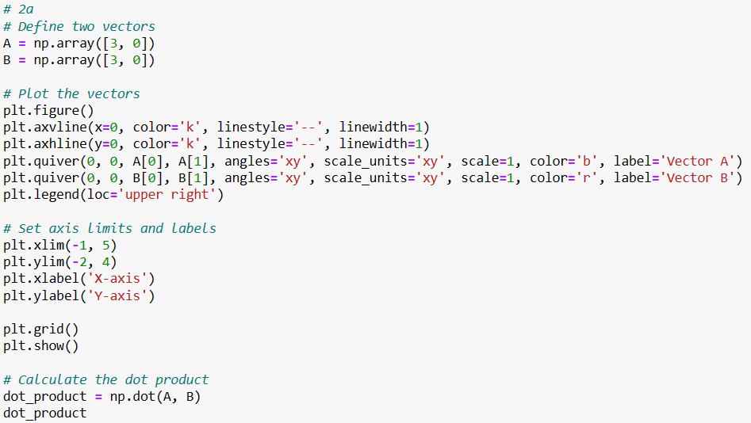

# 06 Vector Spaces

1. Show how you could use the position vectors for (1,0) and (0,1) to reach a particular point in a plot.

Hint: Repeat the example, for something other than (3,4)

1. Show that these two basis vectors are orthogonal using dot product.
2. Choose three vectors to form the basis that could reach anywhere in 3D space (not just stuck to the 2D plot).

Hint: You will need (x, y, z) coordinates for each one.

1. Check that each pairing of your three vectors is orthogonal to each other.

## Solutions

# 07 Differentiation and Gradients

## Discussion and exercise

For the graph y = x^2:

1. What range of x values give a positive gradient?
2. When is the gradient (or rate of change) zero? (What's the value of the x-coordinate?)

1. Using the visual below of f(x) = sin(x), sketch what you think the graph of the gradient will look like.

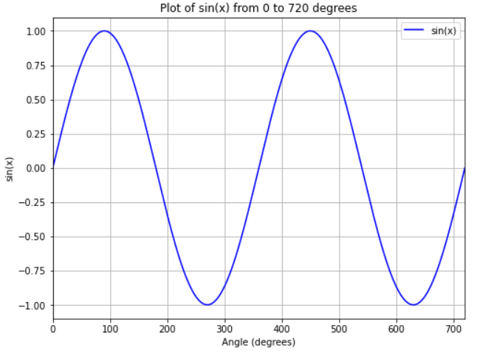

Tips: Draw a matching x axis on a sheet of paper. Mark roughly where the gradient of the graph is zero. Consider where the gradient is positive vs. negative and when it is steeper (larger) or shallower (smaller).

Do you recognise what function the gradient is?

4. Using the visual of f(x) = e^x, sketch the graph of the gradient.

## Solutions

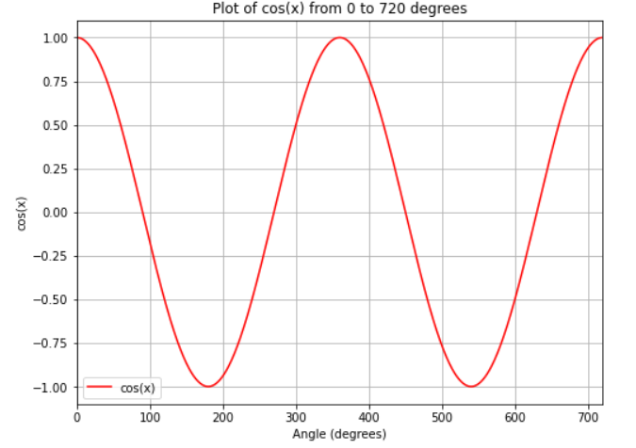

Special case: f(x) = e^x is the only function that is its own gradient!

## Discussion

* Is it possible to imagine the second derivative (green dotted) if you were only looking at the original (blue solid) curve?

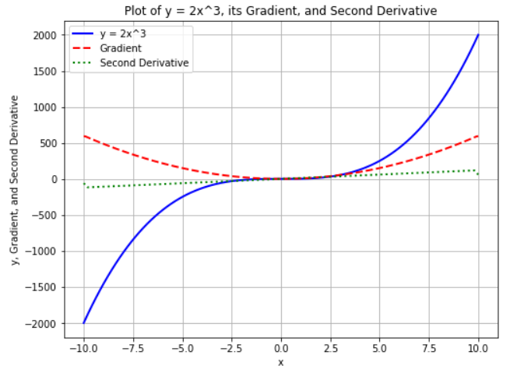

* The second derivative is positive where the original curve is 'underarm' and negative where the original curve is 'overarm’.
* Additionally, an **inflection** point is where the second derivative is zero - where the original curve switches from underarm to overarm or vice versa.
* In this case, the inflection point also happens to be a **stationary point** - where the gradient is zero.

## Paired Exercise

## Solutions

# 08 Introduction to Gradient Descent

## Discussion

1. How can we get a computer to distinguish between whether a stationary point is a minimum, maximum, or inflection?

1. What do you notice about the size of the gradient when you're close to a stationary point (as opposed to further away left or right)?
2. Imagine you're blindfolded walking around undulating grasslands. You score a point if you are the first person to stand in a spot which is completely flat. What strategy could you try?

i) **Method 1**: Calculate the value of f''(x) at that x coordinate - if it's positive the point is a minimum, if it's negative the point is a maximum.

If the second derivative is zero, we need an alternative method:

**Method 2**: Calculate the gradient a little to the left and right of the x coordinate that has been found to be a stationary point.

Minimum: Left negative, right positive

Maximum: Left positive, right negative

Inflection: Left and right have the same sign on the gradient.

ii) The gradient is smaller/less steep near a flat point.

iii) **In gradient descent problems we can consider how the gradient changes as we 'feel' our way through different combinations of values.**

If the gradient is getting less steep, we know we might be approaching a stationary point.

When the gradient is large, we might take bigger steps to speed things up and try to be first.

The tricky thing with gradient descent method is we might 'step over' the stationary point and miss it - the gradient would start getting bigger again.

We could turn back if that happens and start taking smaller steps again.

Sometimes this could be a problem as you might spend ages searching for a stationary point that isn't there, e.g. a non-stationary inflection (shown in the image).

## Exercise

Using the previous example as a template, find the minimum point for x^2 - 2x + 5 using gradient descent

## Solution

# 09 Linear Regression with Gradient Descent

## Exercise

* Unbeknownst to you, this is the code that was used to create the data in our example in this module!

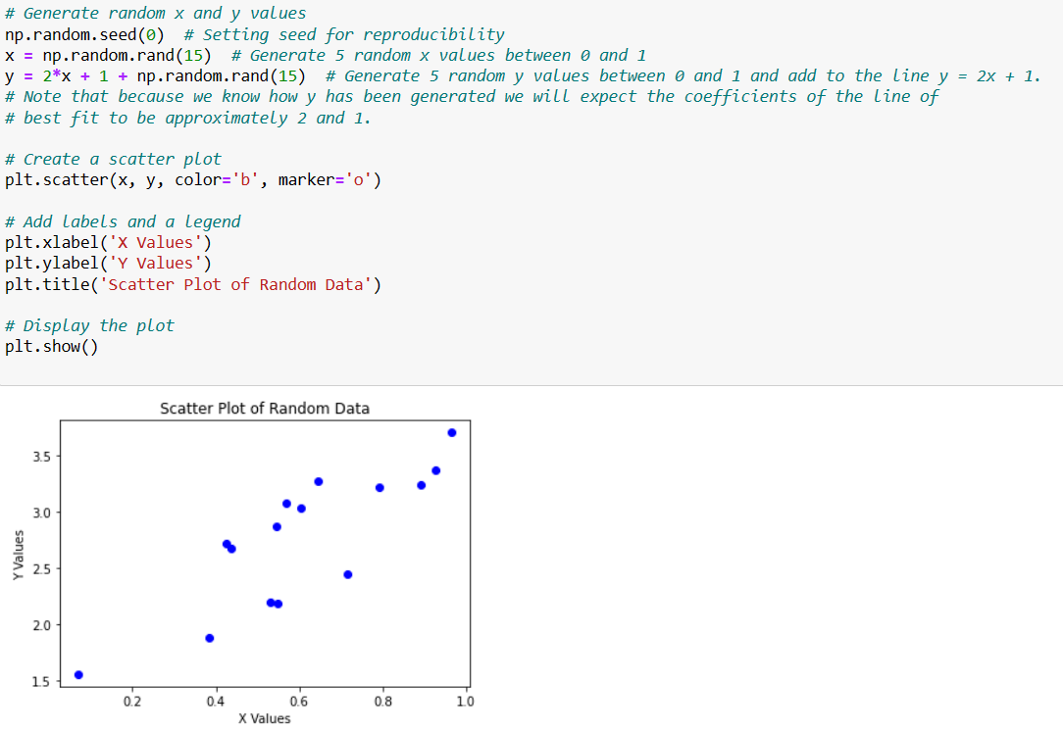

1. Did the method demonstrated in the slides give the expected coefficients? (Accounting for noise from random number generation.)
2. Using the first 3 lines of code above, generate a dataset and work through the gradient descent steps shown in the slides.

Extension Challenge: Use your own coefficients instead of 2 and 1 when generating the data and adjust the gradient of the loss function to match.

# 10 Set Building and Mathematical Notation

## Group Activity

* Investigate any special meanings of letters from the **latin** and **greek** alphabets and examples of other symbols.
* In such cases it would be strange to use these symbols to mean anything else!

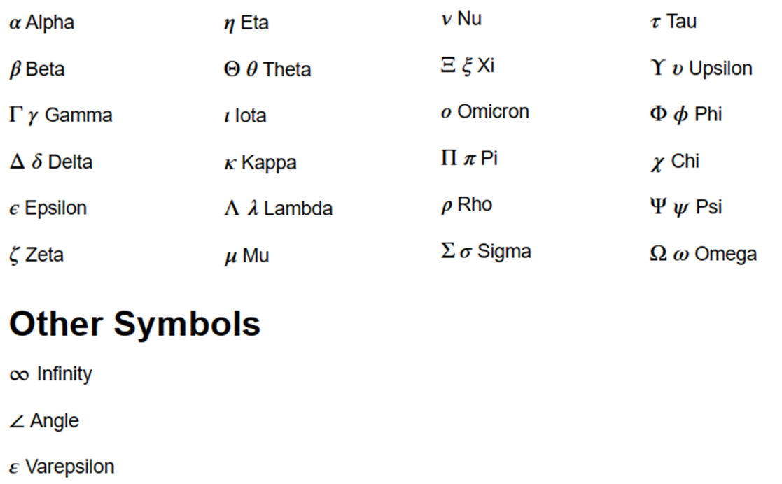

## Example Solutions

## Activity

Use set builder notation and the reference slides to create the set of cub numbers that are less than 100.

## Example Solution

This is an example solution:



If you found another way, discuss alternatives together.

## Group Challenge

## Example Solution

## Activity

Choose one of the functions that you are unfamiliar with and find an example of the symbol in a formula. What is the purpose of the function you have chosen?

## Example Solution

## Activity and Discussion

Consider an article provided by your trainer or 'Mastering the game of Go with deep neural networks and tree search' by D.Silver et al. Published in the journal Nature, volume 529 28th January 2016.

Select an equation and answer the following:

1. Which Greek letters and other symbols have been used? Do any have a standard typical meaning? For example, π
2. Which symbols represent calculations? For example, summations, mathematical operators.
3. Which symbols represent a vector of values for a calculation (or a column of data)?
4. Which symbols represent matrices?
5. Which symbols are function identifiers? For example, for f(x), f is the function identifier and x represents the values that are input into the function.
6. If there are any functions, what are the inputs and what do they calculate?
7. What is the goal of the formula overall?
8. Extension: How is the overall goal achieved?